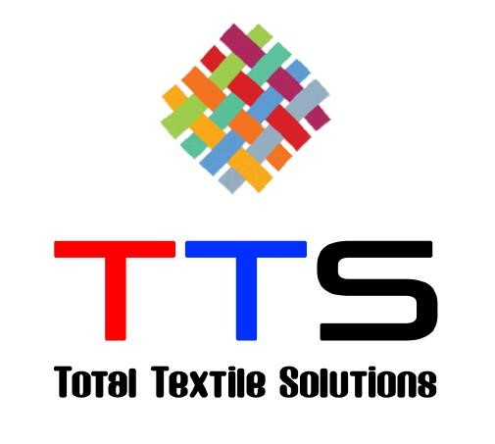

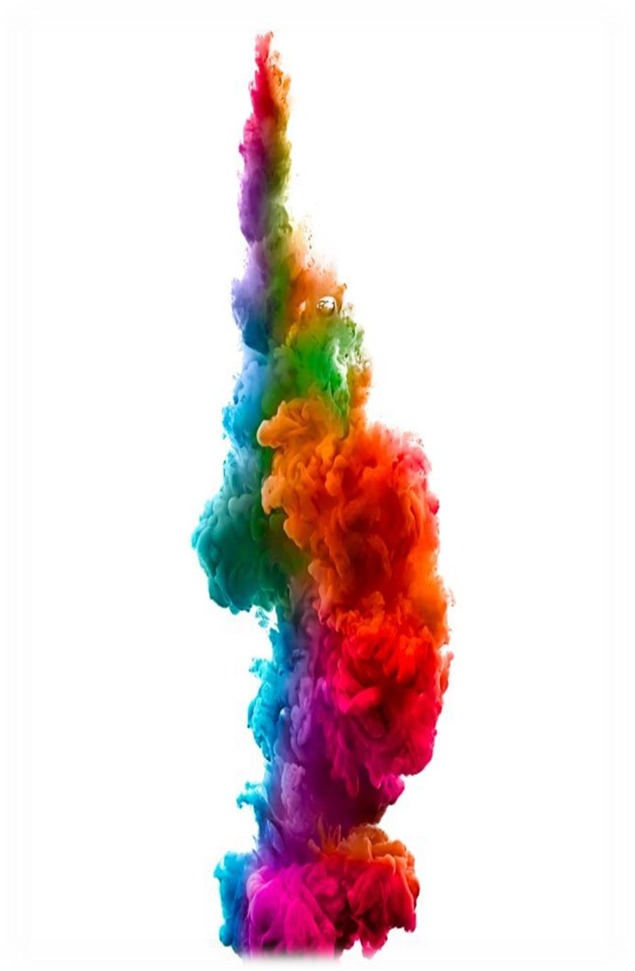COMPANY PROFILE

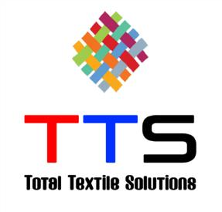 WELCOME TO **TTS**



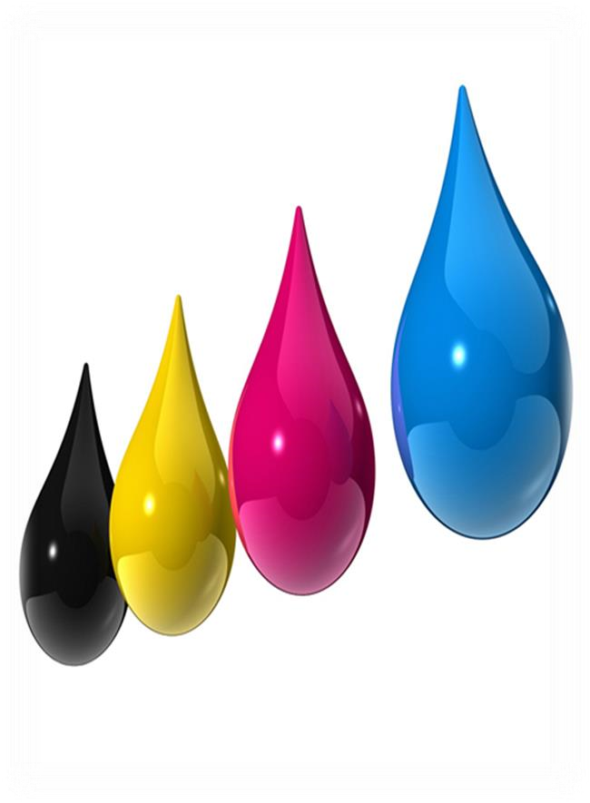 **TTS** is leading dyeing and finishing solution provider offering customers across the island ,broad portfolio of coloring any kind of fabric and manufacturing any kind of industrial accessories.

**TTS** reigns today’s markets due to our concentrated efforts in delivering quality products and other allied services to our customers .it is widely acclaimed for its manufacturing and marketing adroitness. At **TTS** wedeploy the latest technologies conforming to the established industrial standards thus creating a fulfilling and enriching experience for our customers.

# WHAT DRIVES US



**MISSION**

Provide

exceptional

quality

and

service

which

creates

value

to

our

customer’s

business

,creating

and

maintain

fast

,flexible

and

result

oriented

culture

for

best

performance

.

**OUR VALUES**

**&**

**COMPETENCIES**

Trust

and

honesty

Partnerships



**VISION**

Be

the

most

trusted

partner

in

dying

and

finishing

through

innovate

,create

value

and

build

strategic

relationship

to

attain

leadership

in

the

region

whilst

meeting

stake

holders

expectation

.

Mutual respect People

Teamwork knowledge &Experience

Desire for excellence Market Exposure

Trust and honesty

OUR SERVICES



* Fabric dyeing –Nylon, polyester, Cotton & any blends.
* Washing & drying- Fabric & garment  Lace dyeing.

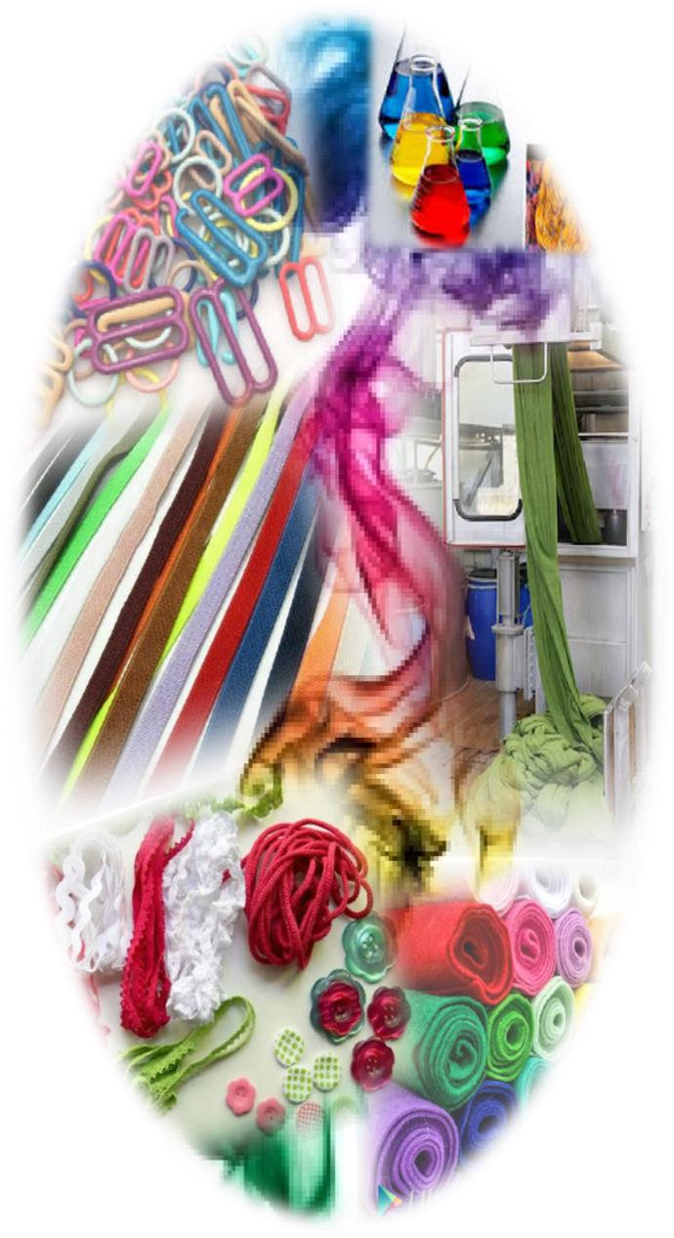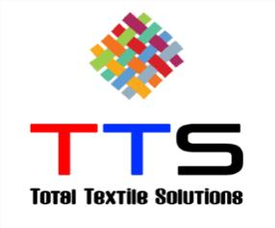

* Elastic dyeing.
* Nylon coated Rings and Slides dyeing.



* Fabric and Other Accessories over dyeing ( Bow,Ribon,Elastic)
* Sample and package dyeing.
* Thread over dyeing (Tkt -120/Tkt -160).



* Union Apparel





OUR CUSTOMERS

* MAS
* Tripal Safety
* Brandix
* Marsylka
* Crystal Martin
* Timex Garment



* Hirdarmani
* Hela Clothing
* Bodyline
* SANASKA



## Our Approach to Customers

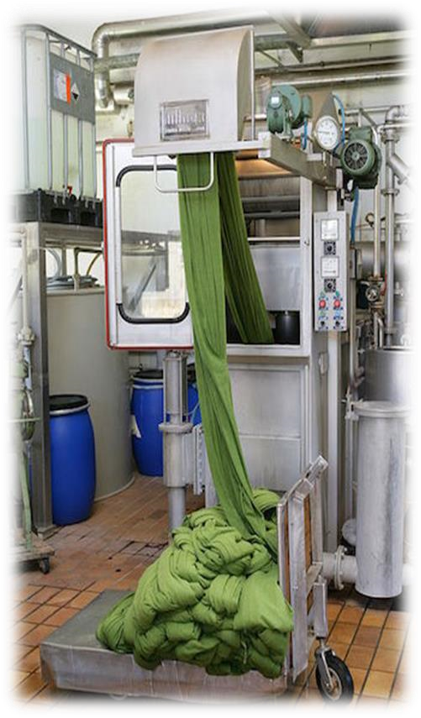

Strive to offer service with a great understanding of your business.

## Service

* Pricing – Highly competitive in the market
* Minimum MOQ/MCQ
* Flexibility and exceptional service
* Over dye light colors to darker shades maintaining mid-spec quality
* Support your other fabric supply on JIT basis (nylon/cotton )on commission dying without MOQ/MCQ
* Accommodate 3m & above

## Lead Times

* 4 days for Lad dip
* 8-10 days on bulk production  Color corrections (Fix) within 2 days

 Quality Process

Raw material

* Dye & chemical –Strength check every lot (1% standard dyeability test)
* Raw Material – Appearance (Spaces & measurements against standards, physical damages)
* Dyeability – (Dye and check for color variation, depth of the color against the standard color)

rd

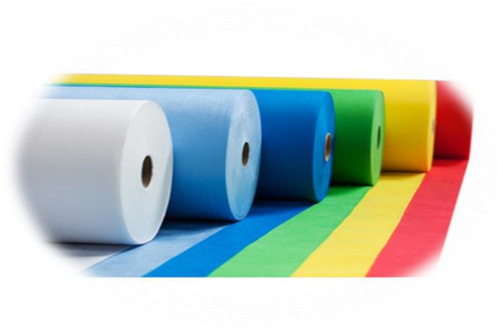

Inspection of finished goods

* Finished goods –Examine 10% from the dyed quantity and check for color variation and damages
* Colorfastness –Accredited laboratory as required (3 party)
* Fabric inspection -10 point system

# CONTACT US

(M) +94 717774120 ( Kamal Ranasinghe )

(M) +94 716437713 ( Madushnka )

(M) +94 710784448 ( Ravindra Bandara)

(P) +94 332231947 (E) sales@tts2020.com sales.tts2020@gmail.com

( Office Address) No. 182 ,

Wanaluwawa,

Wanaluwawa, Kiridiwala, Sri Lanka.